FinSmart: An Intelligent Financial Navigator with MERN Stack



**An Industrial/Practical Training Report**

Submitted to the Faculty of Engineering of

## JAWAHARLAL NEHRU TECHNOLOGICAL UNIVERSITY KAKINADA, KAKINADA.

In partial fulfillment of the requirements for the award of the Degree of

## BACHELOR OF TECHNOLOGY

In

## COMPUTER SCIENCE AND ENGINEERING

By

**P. V. Shyam Sundar Lal (21481A05G1)**

**P. Eswar Reddy (21481A05I5)**

**P. Hemanth (21481A05H0)**

**R. S. G. Karthikeya Naidu (21481A05J3)**

Under the Enviable and Esteemed Guidance of

**DR. G. SRIDEVI, M.Tech., Ph.D.**

Professor**,** Department of CSE

**DEPARTMENT OF COMPUTER SCIENCE AND ENGINEERING**

## SESHADRI RAO GUDLAVALLERU ENGINEERING COLLEGE

**(An Autonomous Institute with Permanent Affiliation to JNTUK, Kakinada)**

**SESHADRIRAO KNOWLEDGE VILLAGE GUDLAVALLERU – 521356 ANDHRA PRADESH**

**2024-25**

# SESHADRI RAO GUDLAVALLERU ENGINEERING COLLEGE

**(An Autonomous Institute with Permanent Affiliation to JNTUK, Kakinada) SESHADRI RAO KNOWLEDGE VILLAGE, GUDLAVALLERU**

## DEPARTMENT OF COMPUTER SCIENCE AND ENGINEERING



**CERTIFICATE**

This is to certify that the project report entitled **“FinSmart: An Intelligent Financial Navigator with MERN Stack** “is a Bonafide record of work carried out by **P. V. Shyam Sundar Lal (21481A05G1), P. Eswar Reddy (21481A05I5), P. Hemanth (21481A05H0), R. S. G. Karthikeya Naidu (21481A05J3)** under

the guidance and supervision of **D r . G . S r i d e v i** in the partial fulfillment of the requirements for the award of the degree of Bachelor of Technology in Computer Science and Engineering of Jawaharlal Nehru Technological University Kakinada, Kakinada during the academic year2023-24.

**Project Guide Head of the Department (DR. G. SRIDEVI) (Dr. M. Babu Rao)**

**External Examiner**

# ACKNOWLEDGEMENT

The satisfaction that accompanies the successful completion of any task would be incomplete without the mention of people who made it possible and whose constant guidance and encouragements crown all the efforts with success.

We would like to express our deep sense of gratitude and sincere thanks to

**D r . G . S r i d e v i ,** Department of Computer Science and Engineering for **her** constant guidance, supervision and motivation in completing the project work.

We feel elated to express our floral gratitude and sincere thanks to **Dr.**

**M. Babu Rao**, Head of the Department, Computer Science and Engineering for his encouragements all the way during analysis of the project. His annotations, insinuations and criticisms are the key behind the successful completion of the project work.

We would like to take this opportunity to thank our beloved principal **Dr.**

**G. V. S. N. R. V. Prasad** for providing a great support for us in completing our project and giving us the opportunity for doing project.

Our Special thanks to the faculty of our department and programmers of our computer lab. Finally, we thank our family members, non-teaching staff and our friends, who had directly or indirectly helped and supported us in completing our project in time.

**Team members**

**P. V. Shyam Sundar Lal (21481A05G1)**

**P. Eswar Reddy (21481A05I5)**

**P. Hemanth (21481A05H0)**

**R. S. G. Karthikeya Naidu (21481A05J3)**



## INTERNSHIP REPORT APPROVAL FORM

Date

With immense pleasure, this is to approve that the students of Seshadri Rao Gudlavalleru Engineering College i.,e

**P. V. Shyam Sundar Lal (21481A05G1)**

**P. Eswar Reddy (21481A05I5)**

**P. Hemanth (21481A05H0)**

**R. S. G. Karthikeya Naidu (21481A05J3)**

successfully completed their Project and Project Report on **“FinSmart: Intelligent Financial Navigator with MERN Stack”** under our guidance.

We are highly impressed with the work that they have done and commend them on their quick grasping skills. They have shown good intent to learn and have put the knowledge gained into application in the form of this project. We appreciate the hard work and commitment shown by them.

We, hereby approve that this document is completely checked and accepted by SmartBridge Technical Team. It’s been an absolute pleasure to educate and mentor these students. We hope that this document will also serve as a Letter of Recommendation, to whomsoever applied.

We wish them success in all future endeavors and a great career ahead.

**Jaya Prakash Netha**

**.Program manager**

## ABSTRACT

Managing personal finances efficiently is a critical skill in today’s fast-paced world. FinSmart is a cutting-edge, web-based financial management application designed to empower individuals to take control of their finances. Built on the MERN stack—MongoDB, Express.js, React, and Node.js—FinSmart seamlessly integrates modern web technologies to deliver an intuitive and feature-rich platform.

The application helps users track expenses, set budgetary goals, and monitor their financial health through interactive dashboards and advanced data visualizations. It offers robust user authentication, dynamic expense tracking capabilities, insightful financial reporting, and real-time alerts for overspending.

With its modular architecture and real-time functionality, FinSmart not only simplifies personal financial management but also enhances user experience by offering high scalability and performance. Each module is designed with clarity and precision, making it an ideal project for understanding full-stack web development principles.

This book presents the design and development process of FinSmart, demonstrating how modern technologies can address practical challenges in personal finance while fostering innovation and learning. Aimed at budding engineers, it is both a technical guide and a vision of financial empowerment through technology.

**INDEX**

**TITLE PAGE NO.**

|  |  |
| --- | --- |
| **CHAPTER 1: INTRODUCTION** |  |
| 1.1 OVERVIEW |  |
| 1.2 PURPOSE  1.3 KEY FEATURES AND FUNCTIONALITIES |  |

**CHAPTER 2: SYSTEM DESIGN**

* 1. SYSTEM ARCHITECTURE
  2. MERN STACK OVERVIEW
  3. MODULE-WISE FUNCTIONAL DESCRIPTION

## CHAPTER 3 : IMPLEMENTATION

* 1. BACKEND DEVELOPMENT
  2. DATABASE INTEGRATION WITH MongoDB
  3. FRONTEND DEVELOPMENT
  4. API INTEGRATION AND MIDDLEWARE

## CHAPTER 4: RESULTS

* 1. FUNCTIONAL OUTCOMES AND SCREENSHOTS
  2. PERFORMANCE METRICS AND TESTING RESULTS

## CHAPTER 5 : APPLICATIONS

**CHAPTER 6 : CONCLUSION & FUTURE SCOPE**

**List of Program Outcomes and Program Specific Outcomes Mapping of Program Outcomes with graduated POs and PSOs**

**CHAPTER 1**

**INTRODUCTION**

**1.1 OVERVIEW**

Effective financial management is critical for achieving personal and organizational goals. In an increasingly digital world, individuals and businesses alike require tools that simplify budgeting, tracking, and analyzing financial transactions. This need inspired the development of **FinSmart**, a comprehensive, web-based financial planning and expense management system.

**FinSmart** uses the MERN stack—MongoDB for data storage, Express.js for backend operations, React.js for a dynamic user interface, and Node.js for server-side execution. The application aims to help users organize their financial lives efficiently by providing key functionalities like expense tracking, budget management, financial visualizations, and real-time alerts for overspending.

The intuitive design and seamless integration of features enable users to:

* Monitor and categorize expenses.
* Define budgets for specific categories and receive alerts when thresholds are reached.
* Access interactive dashboards with dynamic visual representations of spending habits.
* Generate detailed reports, exportable in various formats, for thorough financial analysis.

With its robust architecture, the application ensures scalability, responsiveness, and adaptability for diverse user needs. FinSmart addresses the common pain points of financial planning by delivering a unified platform that combines accessibility with technical sophistication, making personal finance management more achievable than ever before.

## OBJECTIVES AND PURPOSE

**Objectives**

The primary objectives of **FinSmart** are:

* **Empowering Users in Financial Management**: Equip users with an easy-to-use platform to effectively track and control their expenses.
* **Automation and Alerts**: Automate budgeting processes with real-time alerts for overspending, enabling users to stay on top of their finances.
* **Insightful Analysis**: Provide interactive dashboards and detailed visualizations to offer insights into spending patterns and aid in better financial planning.
* **Seamless Accessibility**: Ensure accessibility through a responsive web design, catering to users on various devices.

**Purpose**

The purpose of **FinSmart** is to bridge the gap between the growing complexity of managing personal finances and the need for a simple, efficient, and reliable solution. With its focus on modularity and scalability, FinSmart not only supports individual financial tracking but also aligns with emerging trends in FinTech for future expansion. It serves as an educational initiative for budding engineers, demonstrating the potential of the MERN stack in solving real-world problems.

## KEY FEATURES AND FUNCTIONALITIES

**Key Features of FinSmart**

1. **User Authentication**
   * Secure user registration, login, and logout functionality.
   * User-specific dashboards accessible after successful authentication.
2. **Expense Management**
   * Add, update, view, and delete expenses easily.
   * Categorize expenses by type (e.g., Food, Utilities, Entertainment).
   * Maintain a comprehensive history of financial transactions.
3. **Budget Planning and Alerts**
   * Set budget limits for different expense categories.
   * Receive real-time notifications and alerts when spending approaches or exceeds limits.
   * Compare planned budgets with actual spending through visual indicators.
4. **Financial Reporting**
   * Generate detailed reports of expenses for custom date ranges.
   * Summarize financial activities with totals and averages.
   * Export reports in formats like PDF for offline usage.
5. **Interactive Dashboard with Visualizations**
   * Display spending trends using charts and graphs (bar plots, pie charts).
   * Highlight key metrics like monthly totals and category-wise expenses.
   * Provide a dynamic speedometer for budget status.
6. **Responsive Design**
   * A fully responsive web design that ensures seamless usage across devices, including desktops, tablets, and smartphones.

## CHAPTER 2

## SYSTEM DESIGN

* 1. **System Architecture**

The architecture of **FinSmart** is designed to maximize efficiency, modularity, and scalability while leveraging the capabilities of the MERN stack. The multi-tiered architecture ensures a streamlined data flow between various system layers while maintaining the flexibility to adapt and expand functionalities seamlessly. Here, we break down the architecture into its primary layers, along with the inclusion of additional indicators for social and macroeconomic relevance.

**1. Frontend Layer (React.js)**

* **Dynamic User Interface**:  
  Built using React.js, FinSmart offers a responsive and intuitive interface that provides real-time updates and interactions. Users can perform various financial tasks like viewing dashboards, adding expenses, or setting budgets seamlessly.
* **Component-Based Design**:  
  React’s component-based framework ensures reusability of UI components, promoting development efficiency and maintainability.
* **State Management**:  
  Efficient data management across the application is achieved using state management tools like Redux or Context API. This feature ensures that data, such as budget status or transaction histories, remains consistent across the platform.

**2. Backend Layer (Node.js and Express.js)**

* **Runtime Execution**:  
  Node.js handles server-side scripting and asynchronous operations, ensuring that FinSmart is capable of managing multiple user requests efficiently.
* **Framework for Routing and Logic**:  
  Express.js acts as the core framework for designing RESTful APIs, handling routing, and implementing middleware for tasks such as authentication and data validation.
* **Secure Data Transactions**:  
  RESTful APIs enable structured and secure communication between the client (frontend) and server (backend), ensuring data integrity and efficiency.

**3. Database Layer (MongoDB)**

* **Flexible Data Storage**:  
  MongoDB serves as the storage solution, accommodating diverse data formats for user accounts, expense logs, budgets, and reports. Its document-based NoSQL structure supports scalability and faster querying.
* **Schema Management with Mongoose**:  
  Database models are defined and managed using Mongoose, ensuring consistent data structures while providing robust validation and relationship management.
* **Scalability and Reliability**:  
  MongoDB’s flexibility and horizontal scalability make it capable of handling growing user data without compromising performance.

**4. Integration Layer**

* **Middleware Functionality**:  
  Middleware components validate incoming requests, authenticate users, and handle errors during the communication between frontend, backend, and database.
* **Authentication**:  
  Authentication processes rely on JSON Web Tokens (JWT), securing user sessions and ensuring restricted access to sensitive functionalities.
* **REST API Endpoint Management**:  
  The RESTful APIs act as the critical integration point, ensuring clear and organized communication between system components.

**Architectural Flow**

1. **User Interaction**: Users interact with the frontend interface for tasks such as logging in, managing expenses, or accessing reports.
2. **API Requests**: React.js sends requests to the backend using structured RESTful APIs.
3. **Backend Processing**: Express.js processes these requests by executing business logic, validating inputs, and connecting to the database.
4. **Database Interaction**: MongoDB performs necessary data operations, like retrieving, updating, or storing user-related information.
5. **Results to UI**: The processed response is returned to the frontend, where it is dynamically rendered for the user.

**Social Indicators**

In addition to facilitating financial management for individuals, **FinSmart** can incorporate social indicators that align with users' socioeconomic contexts:

* **Spending Patterns Analysis**: Monitor trends in user spending across social categories like housing, education, and health to generate insights on the financial well-being of communities.
* **Financial Health Reporting**: Provide reports that highlight disparities in financial practices, enabling users to make data-driven adjustments.
* **Localized Budget Suggestions**: Tailor budgeting features to align with local social benchmarks, such as average spending in a given region.

**Macroeconomic Indicators**

FinSmart’s functionality can be expanded to consider macroeconomic contexts, enhancing its real-world applicability:

* **Integration of Inflation Metrics**: Offer users inflation-adjusted budget planning and reporting to understand the real value of their expenses over time.
* **Economic Activity Reflection**: Analyze spending data against larger macroeconomic indicators, such as GDP trends or unemployment rates, to highlight its relevance.
* **Currency Variability Handling**: Include support for currency exchanges and global expenditure tracking, adapting to fluctuations in exchange rates.
  1. **MERN Stack Overview**

The MERN stack—comprising MongoDB, Express.js, React, and Node.js—is a robust and modern framework ideal for developing full-stack web applications. Each component plays a specific role in powering **FinSmart** and works in harmony to provide a seamless user experience:

1. **MongoDB**
   * A NoSQL, document-oriented database.
   * Stores data as JSON-like documents, making it perfect for flexible, hierarchical data storage.
   * Key Use in FinSmart: Storing user information, expense data, budgets, and reports with flexibility and scalability.
2. **Express.js**
   * A lightweight backend web application framework for Node.js.
   * Simplifies routing, request handling, and middleware integration.
   * Key Use in FinSmart: Managing API endpoints, handling business logic, and implementing secure user authentication using middleware.
3. **React.js**
   * A library for building dynamic and responsive user interfaces.
   * Leverages reusable components to create a modular frontend structure.
   * Key Use in FinSmart: Designing interactive dashboards, and forms for data input, and visualizing user data with charts and graphs.
4. **Node.js**
   * A JavaScript runtime for executing server-side code.
   * Provides event-driven, non-blocking I/O for high performance.
   * Key Use in FinSmart: Handling server logic, API requests, and interfacing with the database.

**Why MERN for FinSmart?**

* **Efficiency**: Unified JavaScript language for both frontend and backend simplifies development.
* **Modularity**: Independent components like React on the client side and Node.js on the server side enable modular development.
* **Performance**: Real-time updates, asynchronous processing, and highly scalable architecture ensure smooth operation even with high traffic.
  1. **Module-Wise Functional Description**

The architecture of **FinSmart** is divided into several functional modules, each designed to address specific user needs and contribute to a seamless experience. These modules interact cohesively to deliver a robust, user-friendly financial management platform:

**1. Authentication Module**

The Authentication Module secures the application by managing user access and enabling user-specific functionalities. It supports user registration with form validation to ensure accurate data entry, secure login and logout mechanisms using JWT-based session handling, and role-based access to protect against unauthorized actions.

**2. Expense Management Module**

The Expense Management Module allows users to efficiently track and organize their expenses. It includes features for adding, updating, viewing, and deleting expenses with attributes like category, date, amount, and description. Additionally, it provides filters to sort expenses by categories or date ranges. All operations leverage MongoDB for efficient CRUD functionality.

**3. Dashboard and Data Visualization Module**

This module provides users with an intuitive and comprehensive overview of their financial data. It includes interactive charts and graphs to display spending patterns, such as pie charts for category-wise expense distribution and bar charts for monthly spending trends. Users can also view recent transactions and assess budget performance with real-time updates and visual alerts like budget speedometers.

**4. Budget Management Module**

The Budget Management Module helps users set and monitor their financial goals. Users can define budget limits for different categories and receive alerts when their spending approaches or exceeds these limits. It also compares planned and actual expenditures, offering actionable insights for better financial decision-making.

**5. Reporting Module**

The Reporting Module allows users to generate detailed summaries of their financial activities. It supports custom date ranges for reports and displays key metrics, such as totals, averages, and spending trends. Users can export these reports in PDF format for offline review and sharing.

**6. Notification Module**

The Notification Module keeps users updated about significant financial changes. Real-time alerts are triggered for budget overruns or unusual expenses, while optional reminders can be set for achieving savings goals or receiving monthly summaries.

## CHAPTER 3 IMPLEMENTATION

**3.1 Backend Development with Node.js and Express.js**

The backend ensures seamless data processing, secure transactions, and efficient communication between system components.

**3.1.1 Routing and Business Logic**

* Defined RESTful endpoints to manage functionalities like authentication, expense operations, and budget tracking.
* Modular routes structure (/api/auth, /api/expenses, /api/reports) simplifies adding new features.

**3.1.2 Data Validation and Middleware**

* Middleware functions ensure only valid data is processed.
* Validations include format checking (e.g., expense date format) and completeness (e.g., all required fields are provided).

**3.1.3 Security Implementation**

* Password hashing with **bcrypt** ensures user data security.
* **JWT-based authentication** validates user sessions, protecting sensitive data.

**3.1.4 Error and Request Handling**

* Unified error-handling middleware provides detailed logs for debugging.
* API request logs are generated to track performance and ensure reliability.

**3.2 Database Design and Integration with MongoDB**

The MongoDB database underpins the application's ability to store and retrieve large volumes of diverse data efficiently.

**3.2.1 Schema Design**

* Key collections include:
  + **Users**: Stores user credentials and preferences.
  + **Expenses**: Captures financial transactions with fields like category, amount, date, and description.
  + **Budgets**: Tracks allocated spending limits and current usage.

**3.2.2 Data Relationships**

* User-specific expenses are linked using references.
* Aggregation pipelines compute totals, averages, and patterns across various criteria.

**3.2.3 Indexing and Performance Optimization**

* Indexed commonly queried fields (e.g., userId, date) to ensure fast response times.
* Strategies include using compound indexes for combined queries (e.g., userId and category).

**3.2.4 Data Backup and Scalability**

* MongoDB's replication mechanism ensures data durability.
* Horizontal scaling supports growing user bases and increased operations.

**Suggested Image**: Database schema diagram showing collections, fields, and relationships.

**3.3 Frontend Development Using React.js**

The frontend provides an interactive interface for users, ensuring a seamless and responsive experience across devices.

**3.3.1 Component-Based Design**

* Modular components like **Expense-Table**, **Budget-Tracker**, and **Report-Generator** ensure reusability.
* Organized hierarchy: **Parent-child structure** improves clarity.

**3.3.2 State Management**

* Global state managed using Redux or Context API.
* Features like real-time updates ensure users always see the latest data.

**3.3.3 Responsive Design**

* Implemented using CSS frameworks like Tailwind CSS or Bootstrap.
* Ensures proper rendering on desktops, tablets, and mobiles.

**3.3.4 User Experience Enhancements**

* Interactive visualizations for spending trends using libraries like **Chart.js** or **D3.js**.
* Drag-and-drop or autocomplete features for effortless user input.

**Suggested Images**: Screenshots of the main dashboard, visualization components, and mobile responsiveness views.

**3.4 API Integration and Middleware**

APIs link the frontend with the backend, ensuring smooth and secure communication of data.

**3.4.1 Endpoint Categorization**

* Authentication: Handles login and registration (POST /api/login, POST /api/register).
* Expense Operations: Supports adding, viewing, editing, and deleting (GET/POST/PUT/DELETE /api/expenses).
* Report Generation: Summarizes data (GET /api/reports?startDate&endDate).

**3.4.2 Middleware Functions**

* Validation Middleware: Ensures requests meet required formats (e.g., non-empty fields).
* Authentication Middleware: JWT validation ensures protected access for sensitive operations.

**3.4.3 Integration Testing**

* Tools like Postman test API functionality under various conditions (e.g., invalid login).
* Automated tests ensure compliance with defined behavior and quick identification of issues.

**3.4.4 API Documentation**

* Documented using **Swagger** or **Postman** to provide clear guidelines for API usage.

## CHAPTER 4

## RESULTS

**4.1 Functional Outcomes and Screenshots**

This section outlines the core functionalities of **FinSmart** and showcases the corresponding screenshots to provide a visual understanding of the application’s workflow.

**4.1.1 User Registration and Login**

* Users can securely register with their credentials and log in to their accounts.

**HOME PAGE:**

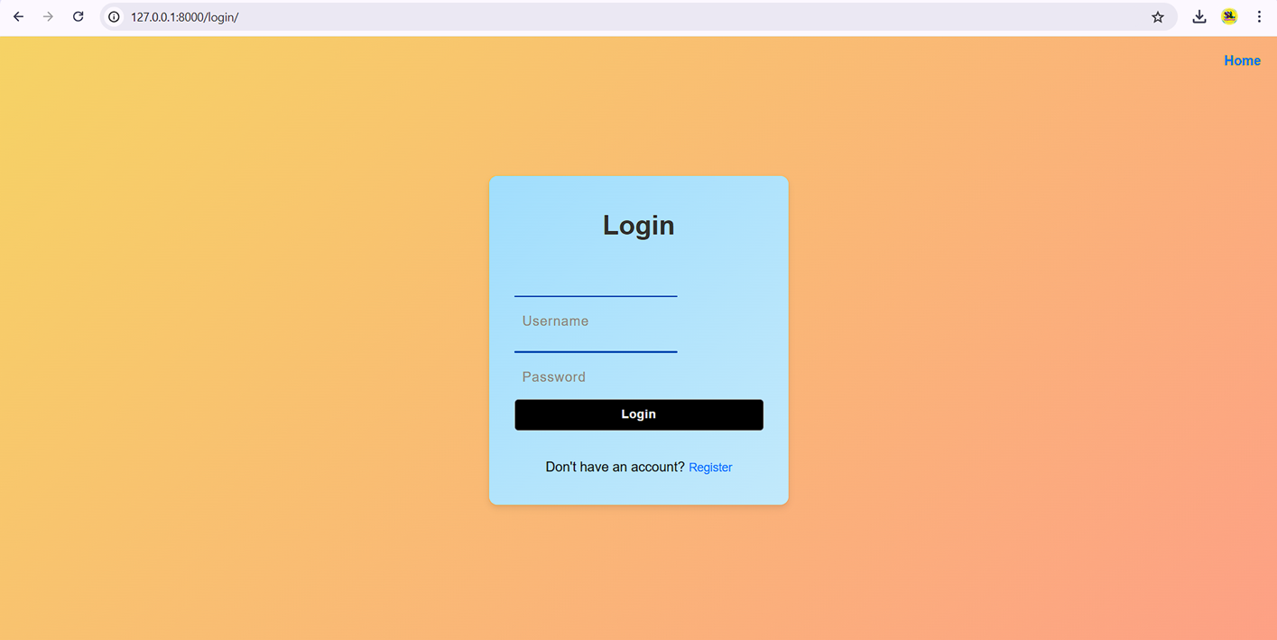**LOGIN PAGE:**

* Login page with fields for credentials and a "Forgot Password?" option.

**REGISTRATION PAGE:**

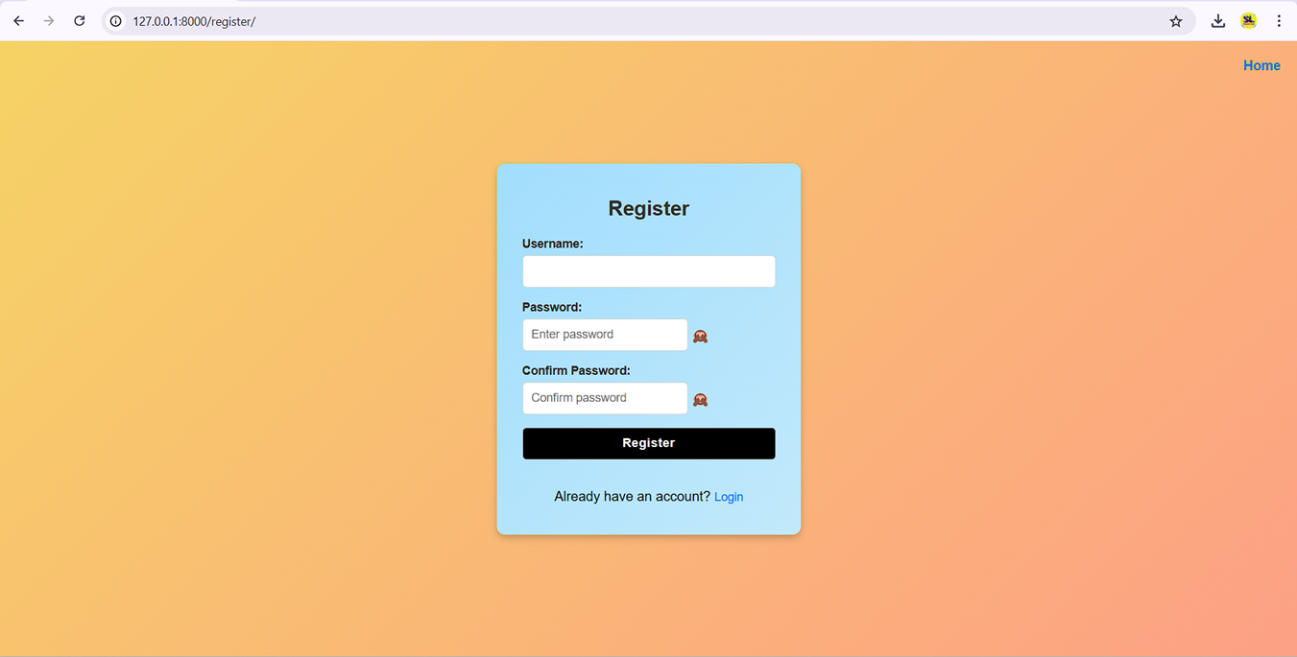

* Registration page showing input fields for username, email, and password.

**4.1.2 Dashboard Overview**

* A personalized dashboard provides an intuitive overview of the user's financial status, including spending summaries and recent transactions.

**PROFILE DASHBOARD:**

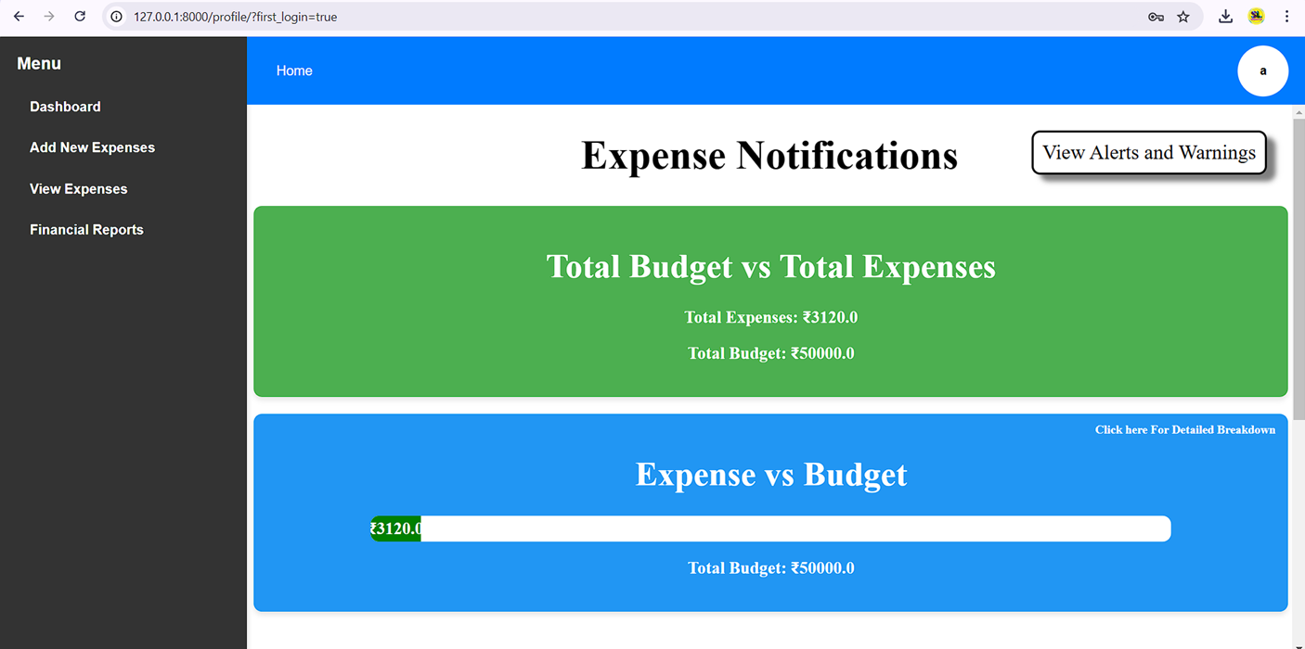

* Dashboard showcasing summary cards (e.g., total expenses, budget utilization) and recent transaction lists.
* Visuals of charts like pie charts for category-wise expenses.

**4.1.3 Adding and Managing Expenses**

* Users can add expenses, edit them for updates, or delete them as needed. Filters allow expense tracking by categories or dates.

**ADD EXPENSES FORM:**

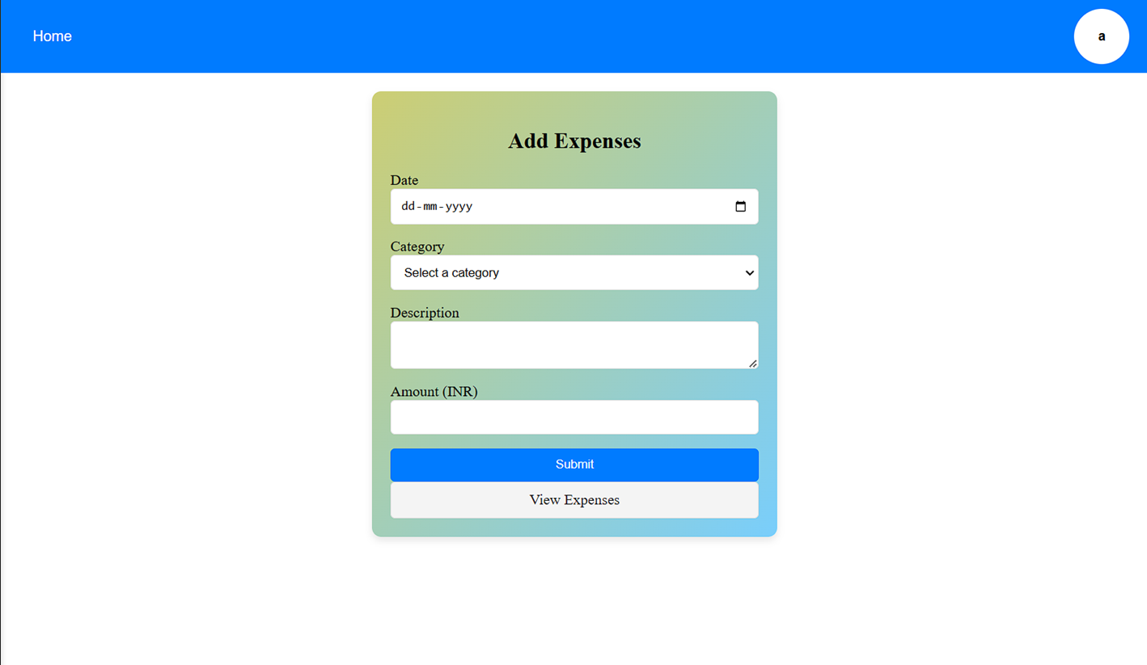

* Expense addition form with fields for amount, date, category, and description.

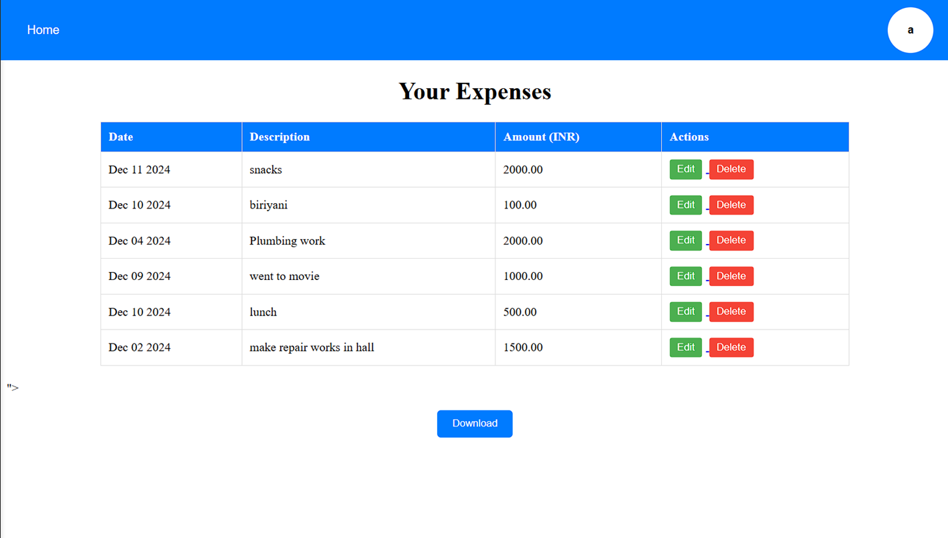**VIEW EXPENSES:**

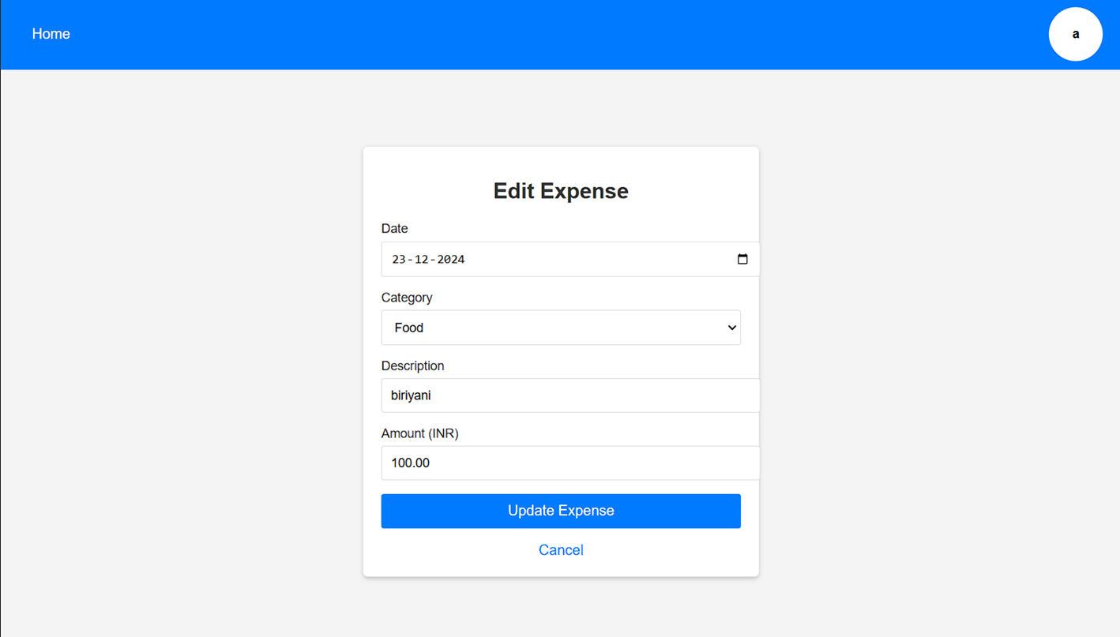**EDIT EXPENSES:**

* Expense management page displaying a list of expenses with action buttons (edit/delete).

**4.1.3 Dashboard Overview with Visualizations**

The dashboard acts as the central hub, displaying vital financial information such as budgets, spending trends, and category summaries in an interactive and visually engaging manner.

**Visualizations on the Dashboard**:

1. 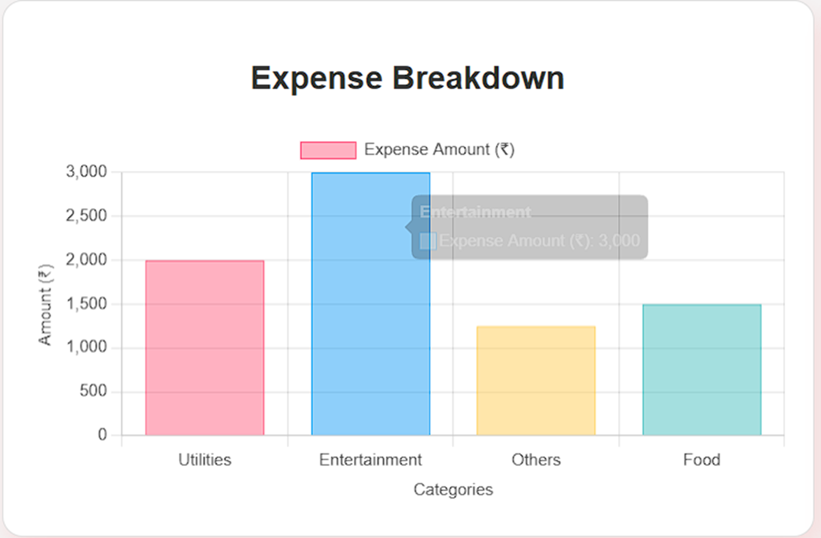**Expense Breakdown Bar Plots**:
   * Visualize category-wise expenses using bar charts, making it easy to identify spending priorities.
   * A bar plot showcasing categories like "Food," "Utilities," and "Entertainment" with their respective spending amounts.
2. **Expense Speedometer**:
   * A dynamic gauge that displays the user's budget utilization with visual cues (green for within budget, yellow for near the limit, and red for exceeded limits).
   * Speedometer on the dashboard indicating current budget status dynamically.

**EXPENSES UNDER THE BUDGET LIMIT:**

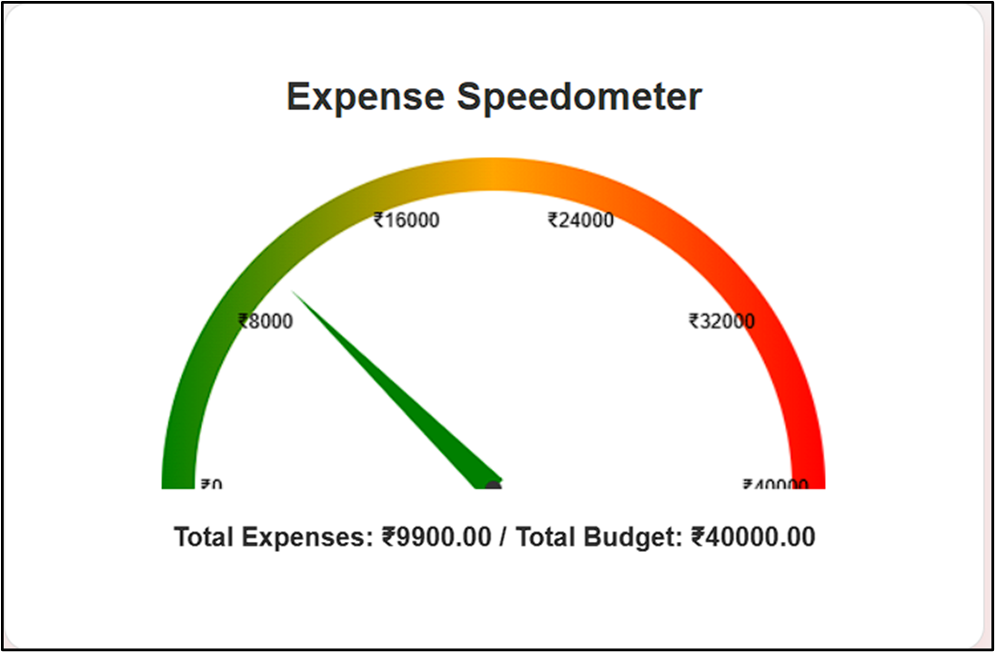

**EXPENSES IN THE WARNING LIMIT OF BUDGET:**

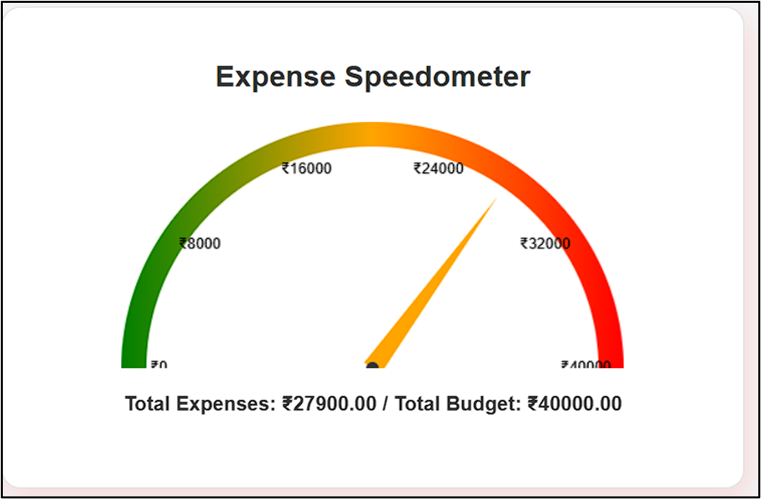

**EXPENSES UNDER ALERT LIMIT OF THE BUDGET:**

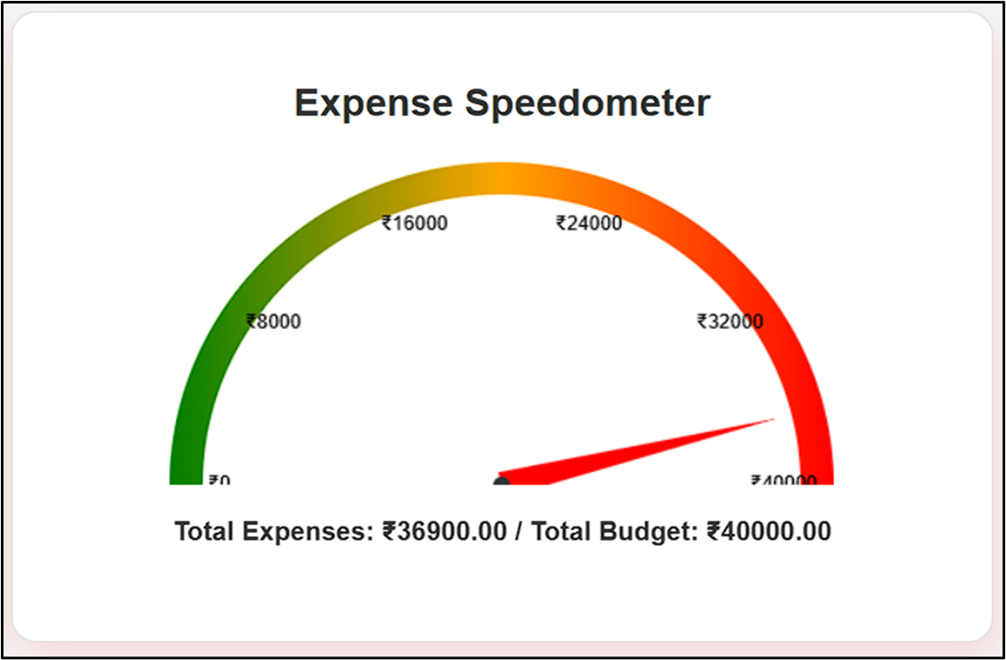

**Recent Transactions Table**:

* + A concise table displaying the latest transactions with columns for date, amount, and category.
  + 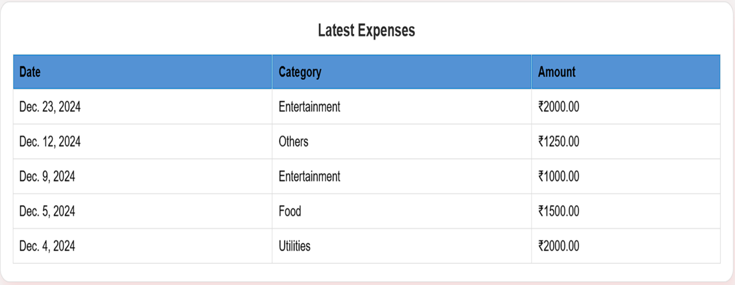Recent transaction list next to charts for user context.

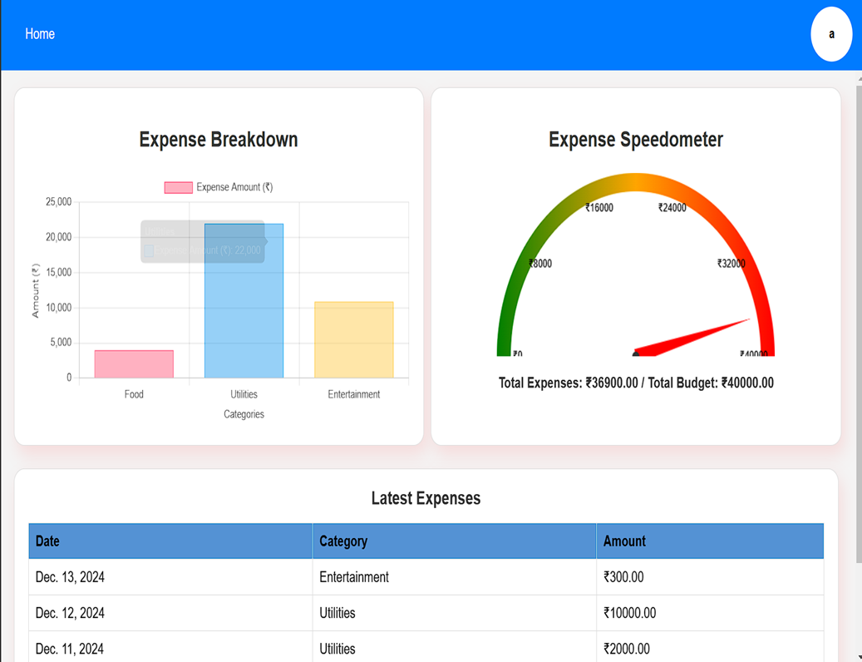**OVERVIEW OF THE DASHBOARD WITH ALL THE DATA VISUALIZATION STANDARDS:**

**4.1.4 Generating Financial Reports**

* Detailed financial reports can be generated for a specific period and exported as PDFs.

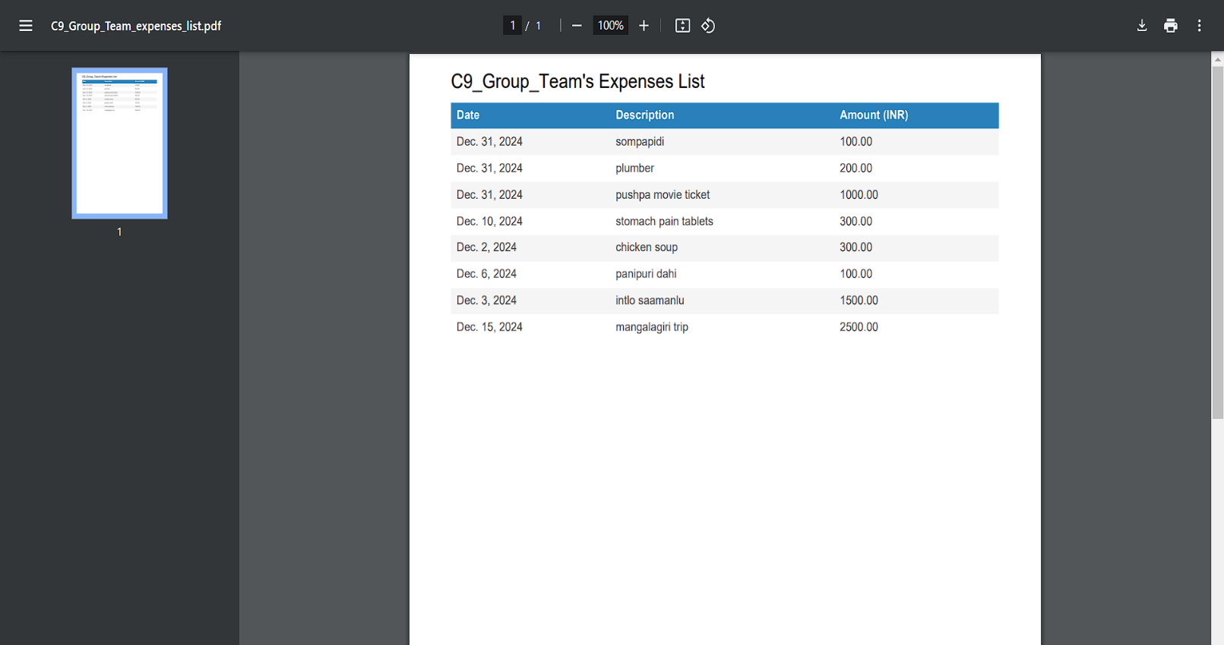**REPORT OF USER’S EXPENSES IN PDF FORMAT:**

* Report page with a summary of key metrics and charts.
* PDF export interface or an example of a downloaded report file.

**REPORT OF USER’S EXPENSES IN EXCEL FORMAT:**

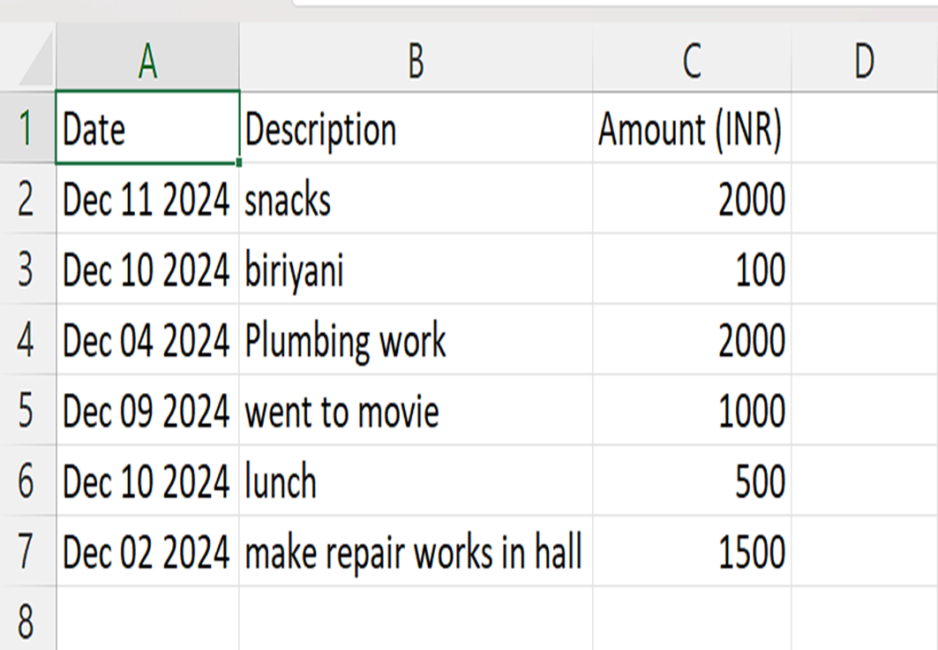

**4.1.5 Budget Management and Alerts**

Users can set spending limits or budget limit for categories and receive visual alerts when budgets are close to being exceeded.

**BUDGET LIMIT SETTING**

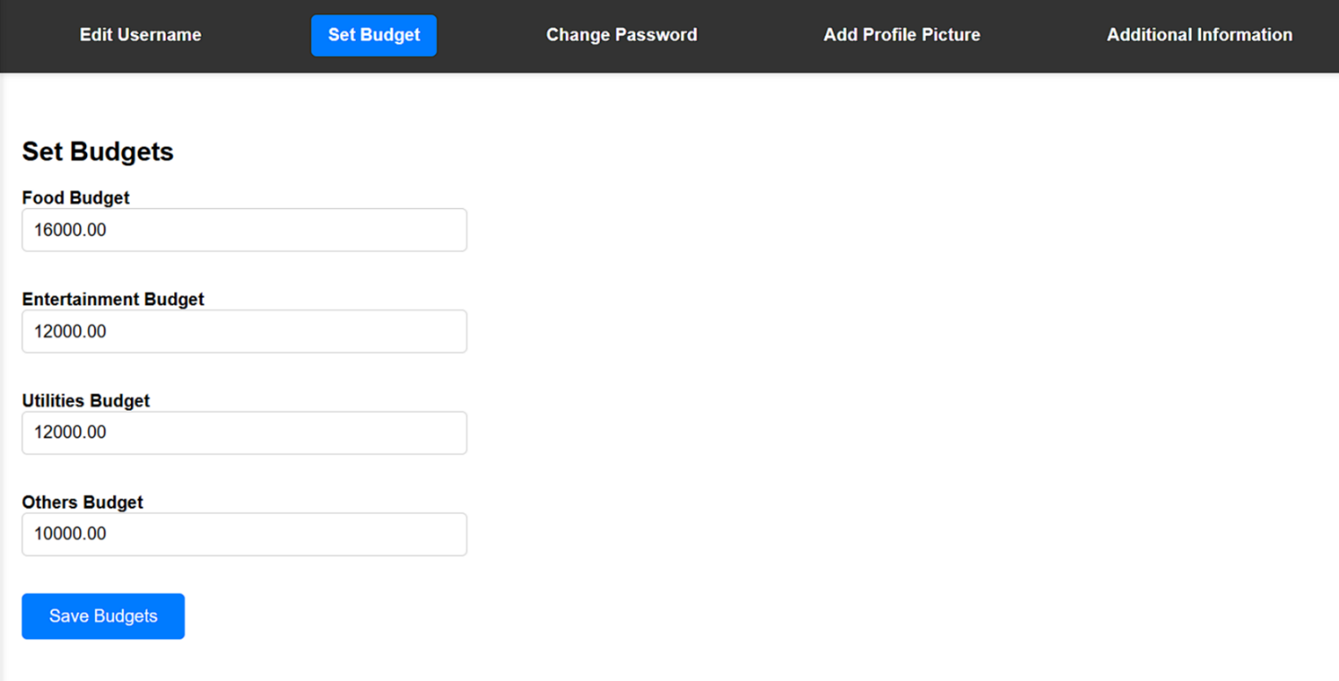

**EXPENSES vs BUDGET:**

* Budget setup form showing input fields for category-specific budget limits.
* 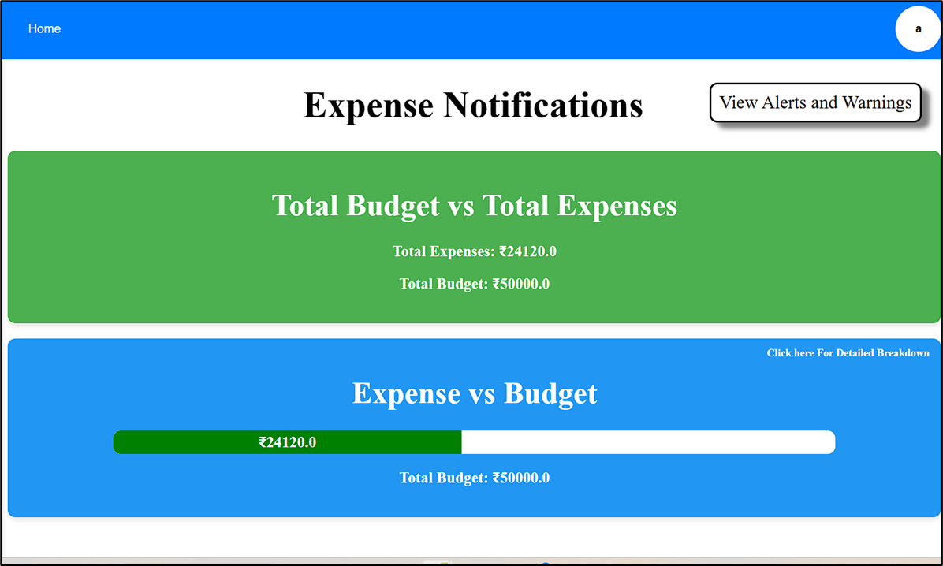**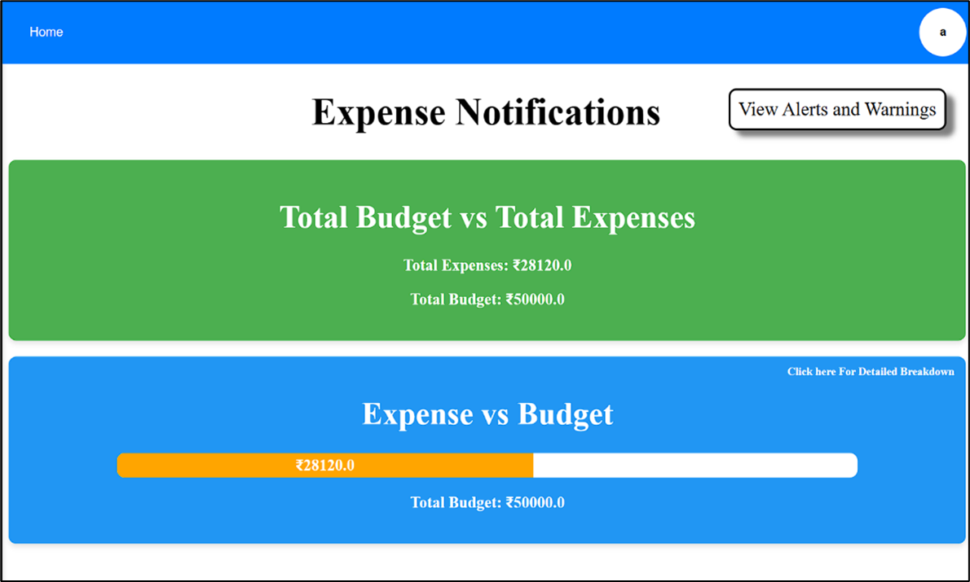EXPENSES vs BUDGET UNDER BUDGET LIMIT:**
* **EXPENSES vs BUDGET IN WARNING:**
* **EXPENSES vs BUDGET IN ALERT:**

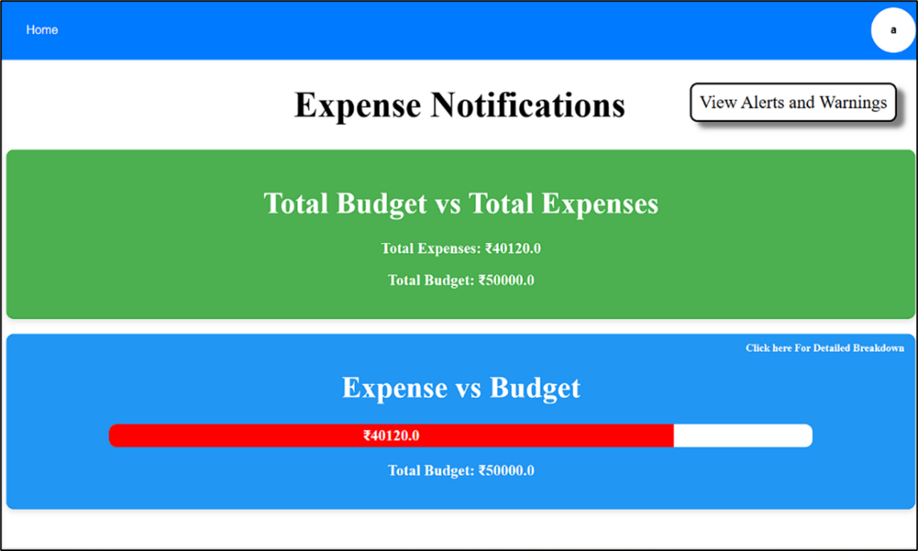

* Alert message (e.g., "You have exceeded your entertainment budget!") or a visual speedometer indicating budget utilization.
* **EXPENSES vs BUDGET CATEGORY WISE:**

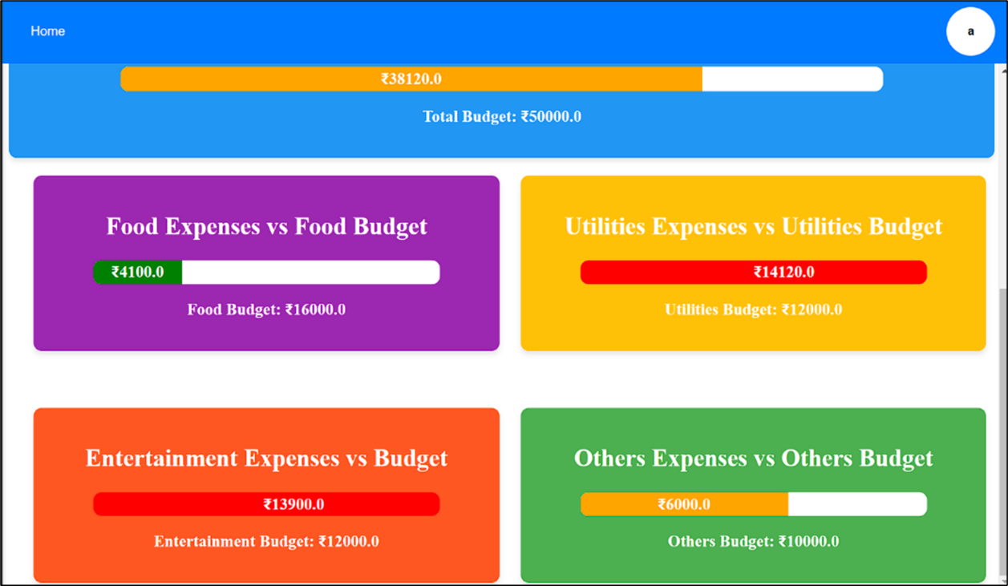

* **WARNINGS AND ALERTS:**

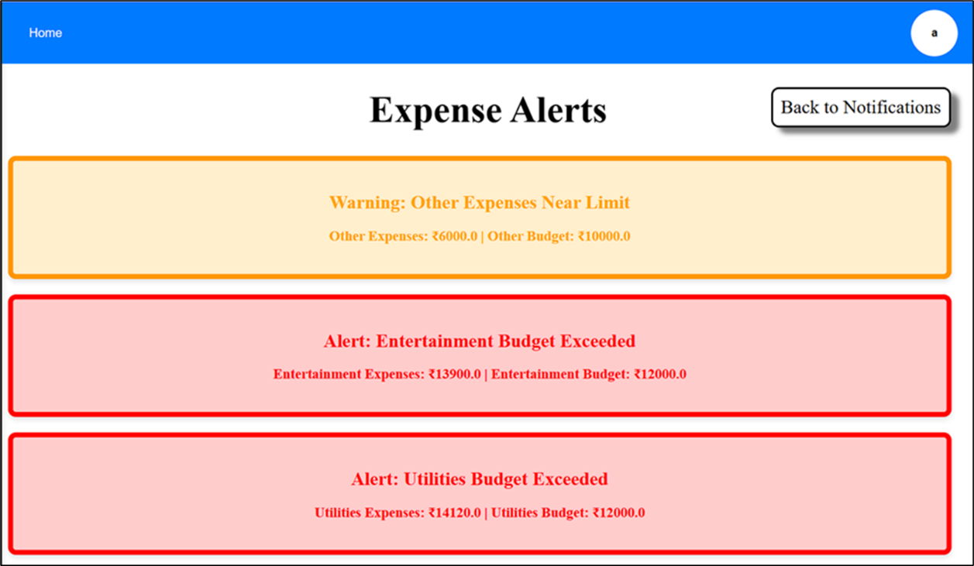

* **ACKNOWLEDGEMENT - NO WARNINGS AND NO ALERTS:**

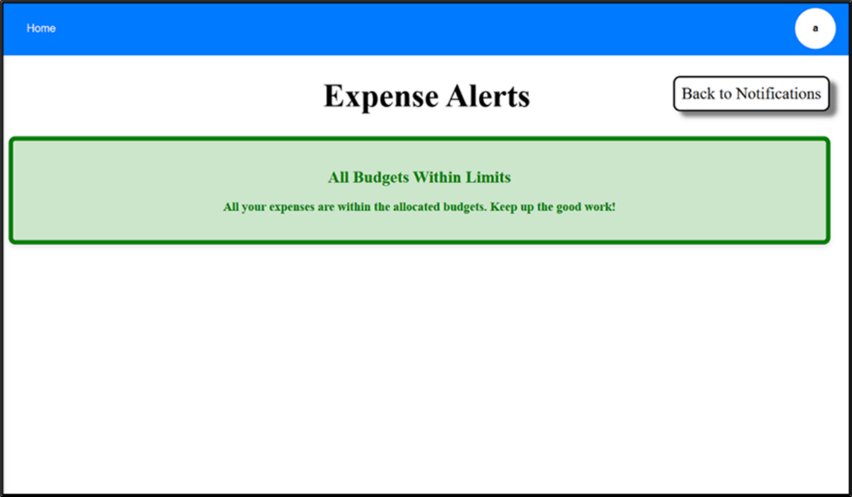

**4.2 Performance Metrics and Testing Results**

This section evaluates the application’s performance metrics to validate its efficiency and reliability.

**4.2.1 API Testing**

* All endpoints were thoroughly tested to ensure smooth data flow between the frontend and backend.
* Postman results for API testing, highlighting response times and successful operations.
* Example of API error handling for invalid inputs.

**4.2.2 Load and Stress Testing**

* Testing ensured the backend could handle simultaneous requests efficiently without downtime.
* Metrics chart from testing tools like JMeter or Apache Bench showing request success rates under heavy load.

**4.2.3 Responsiveness Testing**

* The application was tested on various devices and screen sizes to verify adaptability.
* Screenshots of the app rendered on a desktop, tablet, and mobile view for the same page.

**4.2.4 User Experience Feedback**

* Test users provided input on the UI/UX, and adjustments were made accordingly.
* Before-and-after screenshots illustrating design improvements based on feedback.
* Heatmap from user testing tools like Hotjar showing interaction trends.

**CHAPTER 5**

# APPLICATIONS

**FinSmart** provides a versatile platform with a wide range of applications that cater to personal and professional financial management needs. The core functionality and features enable its use in diverse scenarios.

* **Personal Finance Management**:
  + Expense Tracking: Individuals can monitor their daily expenses and categorize them, helping maintain a record of financial activities.
  + Budgeting: Setting monthly or category-specific budgets ensures disciplined spending habits and prevents overspending.
  + Goal Setting: Assists users in defining and achieving financial goals like saving for a trip or a major purchase.
* **Financial Education Tool**:
  + Interactive Learning: Demonstrates personal financial management concepts, such as budgeting, savings, and expense tracking, through practical application.
  + Visualization of Data: Engages students or new users with intuitive visuals that explain financial behaviours and outcomes.
* **Enterprise and Small Business Applications**:
  + Expense Reporting for Teams: Small businesses can monitor team expenses and generate departmental spending reports.
  + Budget Allocation: Allocating budgets for projects or teams and tracking their usage ensures effective resource planning.
  + Custom Financial Reports: Generate tailored reports for stakeholders or compliance documentation.
* **Behavioural Analysis and Insights**:
  + Spending Habit Analysis: Highlights spending patterns over time, enabling behaviour adjustments for financial improvement.
  + Comparison of Budgets vs. Expenses: Offers insights into financial health by showing deviations from planned budgets.
* **Integration with External Services**:
  + Tax Preparation: Categorized expense reports simplify tax filings by summarizing deductible expenses.
  + Integration with Payment Systems: Compatibility with payment gateways can enable real-time expense updates linked to transactions.
* **Financial Wellness Programs**:
  + Corporate Wellness Initiatives: As part of employee benefit programs, FinSmart can educate employees on financial wellness and tracking.
  + Training Programs: Used in workshops to teach individuals or groups how to manage their finances effectively using real-world tools.
* **Community and Social Applications**:
  + Financial Inclusion Initiatives: Can be adapted for community-based financial education or budget tracking for low-income groups.
  + Charitable Fund Tracking: Nonprofits can use it to track donations and spending transparently.
* **Multi-Currency Support for Global Applications**:
  + International Expense Tracking: Useful for travellers or global businesses to manage expenses in different currencies.
  + Exchange Rate Awareness: Provides insights into cost adjustments based on currency conversions.
* **Educational Research and Case Studies**:
  + Research Projects: Academic researchers can use the tool to analyse financial behaviours across diverse demographics.
  + Case Studies: Financial educators can design scenarios where students analyse data visualized in FinSmart.
* **Application in FinTech Development**:
  + Prototype Testing: Developers can use FinSmart as a baseline prototype for learning and expanding financial tools.
  + Advanced Integrations: Incorporate features like AI-based financial advisors or real-time market trend analysis.

**CHAPTER 6 CONCLUSION & FUTURE SCOPE**

**CONCLUSION**

**FinSmart** represents a comprehensive and robust solution for personal financial management. Designed using the MERN stack, it delivers a seamless experience that combines modern technology with practical functionality. The platform effectively addresses common pain points in financial management, such as tracking expenses, adhering to budgets, and analyzing spending patterns. Through features like dynamic visualizations, real-time alerts, and intuitive dashboards, it empowers users to gain a clear understanding of their financial health and make data-driven decisions.

One of the standout aspects of **FinSmart** is its modular architecture, which ensures scalability and maintainability. Its secure authentication system and efficient data management with MongoDB enhance reliability, while React.js provides a dynamic and responsive interface for users. The incorporation of RESTful APIs bridges the frontend and backend, ensuring smooth and efficient communication. The application excels in presenting actionable insights through interactive charts, graphs, and speedometers, enabling users to maintain financial discipline effortlessly.

Beyond its core functionalities, **FinSmart** offers versatility. It caters not only to individual users managing personal finances but also to small businesses requiring efficient expense tracking and budgeting solutions. Additionally, it has significant potential as an educational tool, helping learners and institutions teach financial management concepts interactively.

Overall, **FinSmart** lays a strong foundation as a scalable and adaptable financial management system. With its flexible architecture and innovative features, the application is poised for further enhancements that can address the evolving needs of users, ensuring its relevance in the dynamic landscape of financial technology.

## FUTURE SCOPE

* **Mobile Application**: Develop a mobile app for enhanced accessibility, including features like push notifications and financial updates.
* **Advanced Analytics:** Implement machine learning algorithms to predict spending trends and provide personalized financial strategies.
* **Multi-Currency Support and Localization**: Add support for multiple currencies and adapt to region-specific financial practices with language preferences.
* **Banking Integration**: Enable users to link bank accounts for real-time expense tracking, bill payments, and automated savings.
* **Community Features**: Introduce shared budgeting for families or teams and create a community for financial advice sharing.
* **Enhanced Reporting**: Provide options to export financial reports in multiple formats (e.g., Excel, CSV) and schedule automated report delivery.
* **Gamification**: Include gamified elements like achievements or rewards to encourage regular and disciplined financial management.
* **AI-Powered Advisory**: Use AI to deliver real-time recommendations for savings, investments, and expense optimization.

## GITHUB LINK:

* + - [Click here to view Content](https://github.com/pvshyamlal/FinSmart-Mern-Internship-Final-Year-Project)

# SESHADRI RAO GUDLAVALLERU ENGINEERING COLLEGE

(An Autonomous Institute with Permanent Affiliation to JNTUK, Kakinada)

Seshadri Rao Knowledge Village, Gudlavalleru

**Department of Computer Science and Engineering**

**Program Outcomes (POs)**

### Engineering Graduates will be able to:

1. **Engineering knowledge**: Apply the knowledge of mathematics, science, engineering fundamentals, and an engineering specialization to the solution of complex engineering problems.
2. **Problem analysis**: Identify, formulate, review research literature, and analyze complex engineering problems reaching substantiated conclusions using first principles of mathematics, natural sciences, and engineering sciences.
3. **Design/development of solutions**: Design solutions for complex engineering problems and design system components or processes that meet the specified needs with appropriate consideration for the public health and safety, and the cultural, societal, and environmental considerations.
4. **Conduct investigations of complex problems**: Use research-based knowledge and research methods including design of experiments, analysis and interpretation of data, and synthesis of the information to provide valid conclusions., component, or software to meet the desired needs.
5. **Modern tool usage**: Create, select, and apply appropriate techniques, resources, and modern engineering and IT tools including prediction and modeling to complex engineering activities with an understanding of the limitations.
6. **The engineer and society**: Apply reasoning informed by the contextual knowledge to assess societal, health, safety, legal and cultural issues and the consequent responsibilities relevant to the professional engineering practice.
7. **Environment and sustainability**: Understand the impact of the professional engineering solutions in societal and environmental contexts, and demonstrate the knowledge of, and need for sustainable development.
8. **Ethics**: Apply ethical principles and commit to professional ethics and responsibilities and norms of the engineering practice.
9. **Individual and team work**: Function effectively as an individual, and as a member or leader in diverse teams, and in multidisciplinary settings.
10. **Communication**: Communicate effectively on complex engineering activities with the engineering community and with society at large, such as, being able to comprehend and write effective reports and design documentation, make effective presentations, and give and receive clear instructions.
11. **Project management and finance**: Demonstrate knowledge and understanding of the engineering and management principles and apply these to one’s own work, as a member and leader in a team, to manage projects and in multidisciplinary environments.
12. **Life-long learning**: Recognize the need for, and have the preparation and ability to engage in independent and life-long learning in the broadest context of technological change.

**Program Specific Outcomes (PSOs)**

PSO1 : Design, develop, test and maintain reliable software systems and intelligent systems.

PSO2 : Design and develop web sites, web apps and mobile apps.

**PROJECT PROFORMA**

|  |  |  |  |  |
| --- | --- | --- | --- | --- |
| **Classification of**  **Project** | **Application** | **Product** | **Research** | **Review** |
| √ |  |  |  |

**Note: Tick Appropriate category**

|  |  |
| --- | --- |
| **Project Outcomes** | |
| Course Outcome (CO1) | Acquire technical competence in the specific domain during the training. |
| Course Outcome (CO2) | Identify the problem statement based on the requirements of the industry |
| Course Outcome (CO3) | Adapt project management skills on par with industrial standards. |
| Course Outcome (CO4) | Develop a system model to obtain a solution and generate areport. |

**Mapping Table**

|  |  |  |  |  |  |  |  |  |  |  |  |  |  |  |  |
| --- | --- | --- | --- | --- | --- | --- | --- | --- | --- | --- | --- | --- | --- | --- | --- |
| **CS3523: INTERNSHIP/ INDUSTRIAL TRAINING/ PRACTICAL TRAINING** | | | | | | | | | | | | | | | |
| **Course outcomes** | **Program Outcomes and Program Specific Outcome** | | | | | | | | | | | | | | |
| **PO1** | **PO2** | **PO3** | **PO4** | **PO5** | **PO6** | **PO7** | **PO8** | **PO9** | **PO1 0** | **PO1 1** | **PO1 2** |  | **PSO 1** | **PSO 2** |
| CO1 | 3 | 2 | 2 | 2 | 2 |  |  | 2 | 2 | 2 | 1 | 2 |  | 2 |  |
| CO2 | 3 | 3 | 2 | 2 | 1 |  |  | 2 | 2 | 2 | 1 | 2 |  | 2 | 2 |
| CO3 | 1 |  | 1 |  | 1 | 1 | 1 | 2 | 2 | 2 | 3 | 2 |  | 2 |  |
| CO4 | 3 | 2 | 3 | 3 | 3 | 2 | 1 | 2 | 2 | 2 | 3 | 2 |  | 2 | 2 |
| **INTERNSHIP/ INDUSTRIAL TRAINING/**  **PRACTICAL TRAINING** | 3 | 2 | 2 | 2 | 2 | 1 | 1 | 2 | 2 | 2 | 2 | 2 |  | 2 | 1 |

**Note: Map each project outcomes with POs and PSOs with either 1 or 2 or 3 based on level of mapping as follows:**

1-Slightly (Low) mapped2-Moderately (Medium) mapped 3-Substantially (High) mapped